Automation to Eprocurement

- Automate eProcurement to send out emails to suppliers automatically.
  - Current process involves, Purchaser manually saving each PO as PDF, manually searching for each supplier’s email from eProcurement and manually sending each PO out as individual emails to suppliers.

  - We want eProcurement to automatically send email to supplier when PO status is changed to PO sent.

  - All of our supplier’s email information are already in eProc. See example of screen grab below:
        - We also want below email field to allow us to add in 3 more email address. Reason is because some suppliers require multiple email contacts for issue of PO.

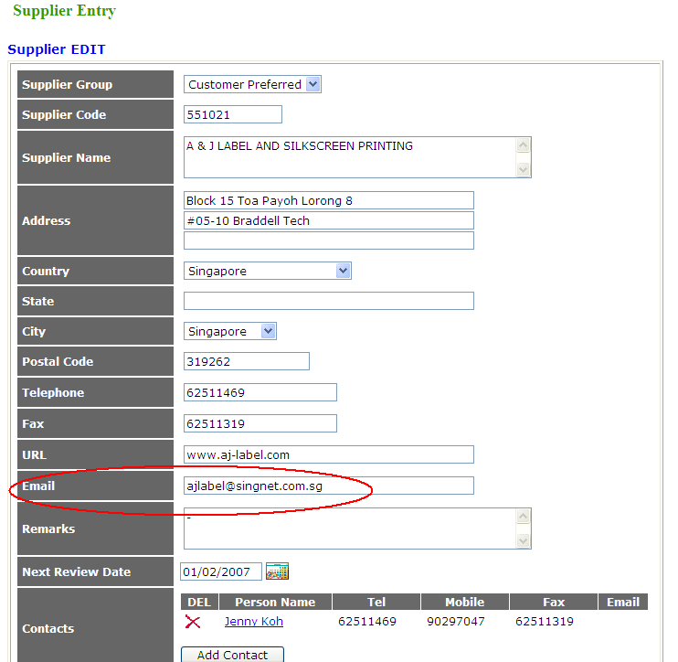

- We want an outlook account to be created for eProc.

- All emails that are automatically send out by eProc are to be captured in this outlook account.

- Jesline and me will have access to this eProc email account and will use this email account when working on PO. This saves the trouble of looking for who (Aidan or Jesline) send out which email to which supplier on what date/time.

- All PO that fail to send out automatic email or any emails that fail to reach supplier’s mail box will have an error message and this error message will appear in this eProc outlook account for either Aidan or Jesline to follow up with a manual email or phone call or fax.

- Content of auto generated email as follows:

  - Subject tittle: Purchase Order from Schenker Singapore Pte Ltd
  - Content is shown below:

Dear Supplier,

Attached PO for your processing and please expedite delivery accordingly.

Important

- If the delivery date is unable to fulfill, do indicate an alternative soonest delivery date.

- Remember to indicate the requestor / receiver's name on your DO.

- If Items had been sent or Job had been done due to URGENCY by Operations (PR NO usually given to be indicated on your DO), please indicate this PO NO on all your documents (if possible) and a copy of DO must be attached along with your original Tax Invoice to Schenker's Finance Department when you bill us.

Best Regards,

Schenker Singapore Procurement Department
Schenker Singapore (Pte) Ltd
17 Changi South Street 2, Singapore 486129
___________________________________________
www.dbschenker.com

Delivering solutions @www.deliveringsolutions.dbschenker.com
DB Ecoprogram @ www.dbecoprogram.com

[Please Consider The Impact To The Environment Before Printing This Email...]

This is an auto generated email. If you require clarifications, please contact:

Aidan Yu
Senior Procurement Executive
Phone (DID) +65 65491318
Mobile +65 96866874
Email: aidan.yu@dbschenker.com

Jesline Hoe
Procurement Executive
Phone (DID) +65 65491464
Email: jesline.hoe@dbschenker.com

- Requestor’s email must also be in the Cc of the auto-generated email to supplier.
  - Requestor’s email address are already captured in eProc (see below)
  - The system must be able to pull out data and populate it into the Cc field of the auto email.

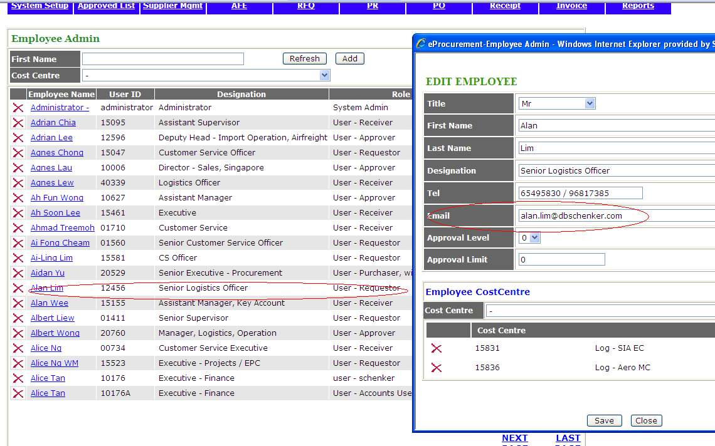

2) We urgently need a in the PR screen a box that shows if the PR is Std or Non Std PR.

See below screen capture. There is no information that shows if the PR is Std or Non Std. The purchaser has to use his/her own experience or knowledge to make guesswork whether the purchase is standard or non-standard.

If it is Std PR, purchaser can process this PR into PO relatively easily.

However, if it is a non-standard PR, the purchaser has to go to the RFQ screen and search for the relevant RFQ to search for quotations to check price.

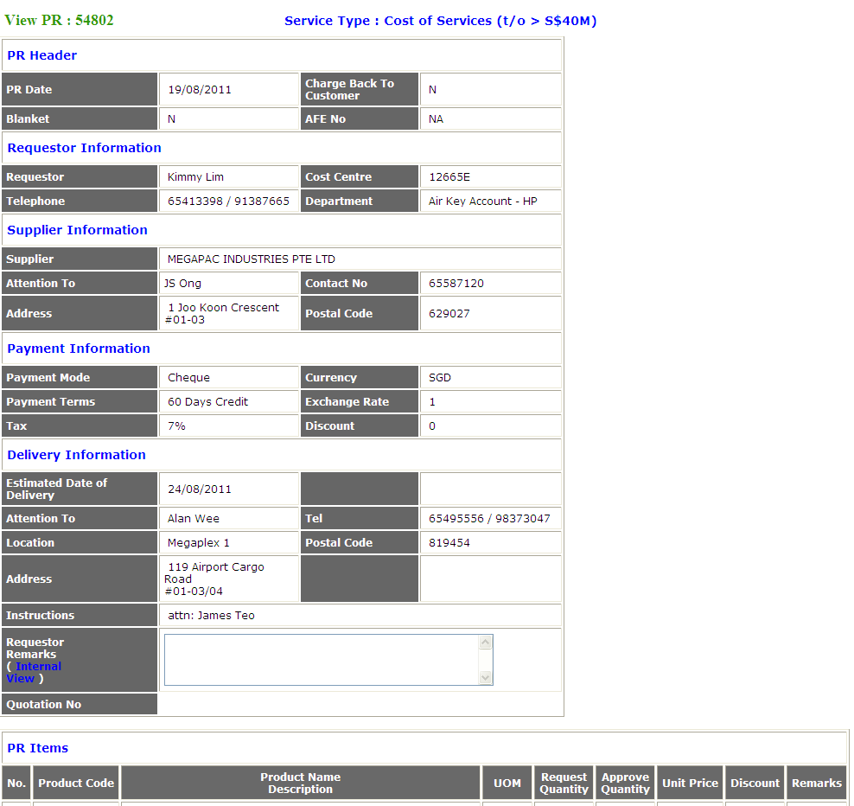

3) Once a PR is identified as Non Std PR, we do not want to manually go to RFQ screen to search for the correct RFQ.

We need either:
- A box in the PR screen that shows the RFQ number, so that we can go to RFQ screen, key in the RFQ and pull out RFQ without having to search for it.

- Or even better if the RFQ can be attached to the PR

- Or a link that could bring us to the relevant RFQ

- When purchaser changes the unit price of product, purchaser goes to:
  - Approved List > Product > Product Edit > save (see screen capture)
  - However when a PO requestor goes into eProc, the requestor will still see the old price.
  - Purchaser needs to do an extra step of going to Approved List > Product > Product Price Admin and change price again
  - Price change should be effective when purchaser changes price in either Product edit or Product Price admin. Purchaser should not need to go to both screens.

